**Name: Sulav Adhikari**

**Roll Number:23081003**

**Subject: Statistics II, Lab 1 (B.Sc. CSIT III Sem)**

**Section: B**

Q.No.1:

**Working Expression:**

C.I for Population mean=mean ± Ztab*standard error

**Working Procedure:**

Define variables height in variables view → Type, numeric → Label, height of students → measure, scale → input data in data view → analyze → Descriptive Statistic → Explore → Put Variation into dependent list→ Statistics→ Fixed 95%C. I → Continue → OK

**SPSS OUTPUT:**

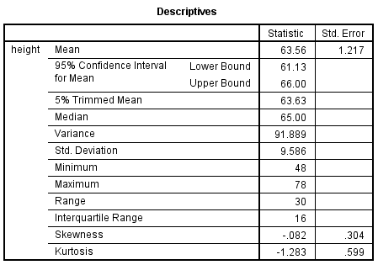

**Conclusion:**

Hence 95% confidence interval for population mean is 61.0416 to 66.5094.Name: Sudip Jung Khatri

Roll Number:23081032

Subject: Statistics II, Lab 1 (B.Sc. CSIT II Sem)

Section: B

Q.No.:2

**Working Expression:**

C.I for Population mean=mean ± Z-tab*standard error

**Working Procedure:**

Define variables download speed of networks in variables view → Type, numeric → Label, Speed of network in Mbps → measure, scale → input data in data view → analyze → Descriptive Statistic → Explore → Put Variation into dependent list→ Statistics→ Fixed 99%C. I → Continue → OK

**SPSS OUTPUT:**

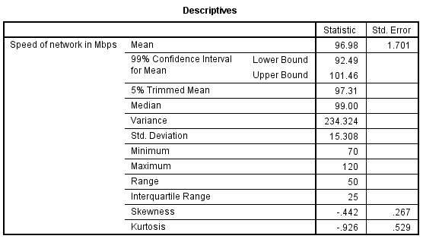

**Conclusion:**

Hence 99% confidence interval for population mean is 92.49 to 101.46.